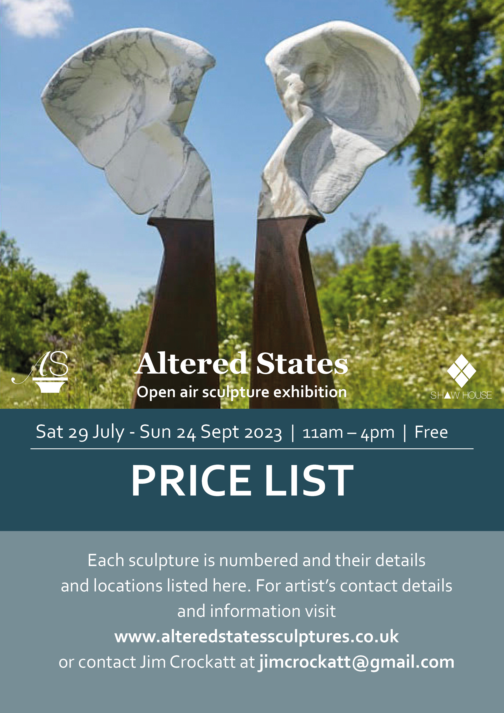
No. | Artist | Title | Medium | Price
1 | Diana Barraclough | Up the Down River | Ceramic | £700
2 | Diana Barraclough | Mandala | Ceramic | £800
3 | Diana Barraclough | Birds Eye View | Ceramic | £700
4 | Stacy Beaumont | Rainbow Spirit | Delabole Slate & Glass | £1500
5 | Stacy Beaumont | Sullis | Delabole Slate, Glass & Gold Leaf | £1750
6 | Stacy Beaumont | Ti Pedin | Delabole Slate &Glass | £1800
7 | Friedel Buecking | Brian Cox Dreaming the Universe | Oak,beech, sweet chestnut and paint | £900
8 | Friedel Buecking | High Moon | Oak | £1200
9 | Friedel Buecking | Sweetheart | Oak | £1800
10 | Friedel Buecking | On Blue Hill | Oak | £1000
11 | Diccon Dadey | Gorilla | Steel | £5500
12 | Diccon Dadey | Shark | Steel | £2400
13 | Diccon Dadey | Turtle | Steel | £2200
14 | Diccon Dadey | Swooping Owl | Steel | £814
15 | Alex and Emma Devereux | Tri Squid | Tricoya MDF, steel, gas lamp, gas | £20400 | 1/3
16 | Emma Elliott | Elephantom (ii) | Arabescato marble, steel base | £11000
17 | Emma Elliott | Pow! | Statuario Marble | £10000
18 | Emma Elliott | Trumpetting | Arabescato marble | £7000
19 | Pam Foley | Anchored | Marble resin | £1600 | 1/5
20 | Pam Foley | Protection | Marble resin on oak wood base | £495 | 6/15
21 | Pam Foley | Silent Grief | Marble resin | £650 | 2/5
22 | Deborah Frith | Women’s Work | Steel | £5000
23 | Paul Harvey | Raven | Cold cast Black metals | £1600
24 | Paul Harvey | Red Kite | Cold cast Black Metals | £1900
25 | Paul Harvey | White Gannetts | Cold cast White Marble | £1300
26 | Paul Harvey | Kestral Landing | Cold cast Pewter | £950
27 | Paul Harvey | White Tawney | Cold cast White Marble | £850
28 | Paul Harvey | Kestral Landed | Cold cast Mixed Metal | £650
29 | Paul Harvey | Singing Blackbird | Cold cast Black Metals | £950
30 | Paul Harvey | Wren | Cold cast Mixed Metals | £250
31 | Paul Harvey | White Dove | Cold Cast White Metals | £330
32 | Deborah Harrison | Angel & Child | Blue marble | £8500
33 | Andy Hopper | Interstellar | Stainless Steel on Stone Plinth | £20000
34 | Andy Hopper | Song to the Creator | Stainless Steel, Bronze on Oak | £15500
35 | Jonty Hurwitz | Singularity in Bronze | Bronze and stainless steel | POA | Edition of 9+4AC
36 | Jonty Hurwitz | Rejuvenation in Bronze | Bronze and stainless steel | POA | Edition of 9+4AC
37 | Jo Jones | Squat | Bronze resin | £935
38 | Mike Long | Le Bouche Or | Bronze resin/gold leaf | £5950 | 1/2
39 | Mike Long | Reach | Bronze | £16500 | 2/9
40 | Mike Long | The Water Girl | Bronze | £16,500 | 1/9
41 | Fidelma Massey | The Ram Bishop | Ceramic | £960 | 9/9
42 | Fidelma Massey | Manbird | Bronze | £4360 | 4/9
43 | Fidelma Massey | Shrine of the Mother of Birds | Bronze | £6276 | 9/9
44 | Colin Underhay | Chair | Oak | £400
45 | Colin Underhay | Large Bench | Oak | £650
46 | Colin Underhay | Bench | Oak | £600
47 | Gavin Wilkinson | Reliant | Wood, metal, stone, ceramic | £350
48 | Gavin Wilkinson | Just Friends | Wood, metal, stone, ceramic | £600
49 | Gavin Wilkinson | Reprise | Wood, metal, stone, ceramic | £600
50 | Gavin Wilkinson | Receive | Wood, metal, stone, ceramic | £450
51 | Gavin Wilkinson | Conversation | Wood, metal, stone, ceramic | £600
52 | Gavin Wilkinson | Passenger | Wood, metal, stone, ceramic | £450
53 | Gilbert Whyman | Girl in a Hat | Bronze resin | £1600
54 | Gilbert Whyman | Sissetta Stretching | Bronze resin | £1950
55 | Gilbert Whyman | Life Girl Standing | Bronze resin | £1950
56 | Steve Yeates | Scorpion | Aluminium and mixed media | £2995
57 | Steve Yeates | The Firebird | Chameleon effect and mixed media | £2995
58 | Steve Yeates | Giselle | Fiberglass and mixed media | £3995
59 | Jim Crockatt | Wings | Oak | £600
60 | Jim Crockatt | Thrust | Oak | £700
61 | Jim Crockatt | Fidelity | Oak | £650

All the sculptures are original unless otherwise stated in the editions column.
Visitors are requested to treat the sculptures with the respect that they deserve.
It is an organic show in so far as new sculptures will be added over the duration of the show.
So come and come again!
Thank you and enjoy the show,
Jim Crockatt, Curator.

Jim Crockatt is also a presenter on Kennett Radio and has a show called “Art for Art’s Sake”, which is live on air the second Thursday of each Month 7-8 pm where he interviews artists, poets, actors and musicians around a Desert Island Discs format.
Herewith are previous programs that can easily be accessed. Happy listening.

“Art for Art’s Sake” Arts Programmes:
- John Brazendale -- Potter
https://www.mixcloud.com/kennetradio/art-for-arts-sake-9th-september-2021
- Isobel Catriona -- Artist
https://www.mixcloud.com/kennetradio/art-for-arts-sake-14th-november-2021
- Paul Forsay -- Artist
https://www.mixcloud.com/kennetradio/art-for-arts-sake-9th-december-2021
- Adam Kotz -- Actor
https://www.mixcloud.com/kennetradio/art-for-arts-sake-13th-january-2022
- Johannes Von Stumm -- Sculptor
https://www.mixcloud.com/kennetradio/art-for-arts-sake-10th-february-2022
- Holly Payton -- Fringe Director
https://www.mixcloud.com/kennetradio/art-for-arts-sake-10th-march-2022
- Gina Soden -- Photographer
https://www.mixcloud.com/kennetradio/art-for-arts-sake-14th-april-2022
- Mark Eynon -- Festival Director
https://www.mixcloud.com/kennetradio/art-for-arts-sake-12th-may-2022
- Gail Davis -- Artist
https://www.mixcloud.com/kennetradio/art-for-arts-sake-10th-june-2022
- Lisa Mounteer Watson -- Artist
https://www.mixcloud.com/kennetradio/art-for-arts-sake-14th-july-2022
- David Hatfull -- Photographer
https://www.mixcloud.com/kennetradio/art-for-arts-sake-13th-october-2022
- Gavin Wilkinson -- Artist & Musician
https://www.mixcloud.com/kennetradio/art-for-arts-sake-10th-november-2022
- Steve Wallis -- Poet
https://www.mixcloud.com/kennetradio/art-for-arts-sake-8th-december-2022/
- Ken Rich -- Poet
https://www.mixcloud.com/kennetradio/art-for-arts-sake-12th-january-2023
- Lisa Harrington -- Theatre Director
https://www.mixcloud.com/kennetradio/art-for-arts-sake-9th-february-2023
- Vicky Baker -- leather bag maker and costume maker
https://www.mixcloud.com/kennetradio/art-for-arts-sake-9th-march-2023/
- Emma Clifton Brown -- artist drawer.
https://www.mixcloud.com/kennetradio/art-for-arts-sake-16th-march-2023
- Laura Cranstoun -- Abstract Multimedia Painter
https://www.mixcloud.com/kennetradio/art-for-arts-sake-23rd-march-2023/
- Nick Schlee -- Painter
https://www.mixcloud.com/kennetradio/art-for-arts-sake-20th-april-2023/
- Cat Croxford -- Landscape Painter
https://www.mixcloud.com/kennetradio/art-for-arts-sake-4th-may-2023/
- Emma Green -- Printer and Mixed Media
https://kennet.redio.co/listen/again?date=Thu,%2011%20May
- Sydney Klugman -- Painter
https://www.mixcloud.com/kennetradio/art-for-arts-sake-13th-july-2023/.

